https://www.jdoodle.com/embed/v0/604n
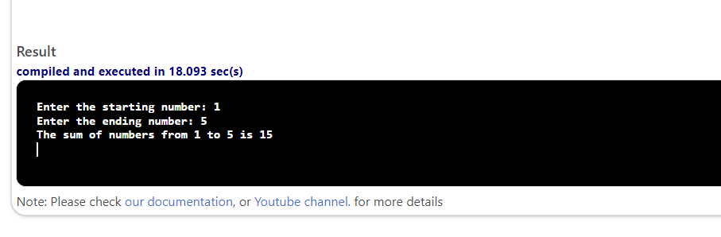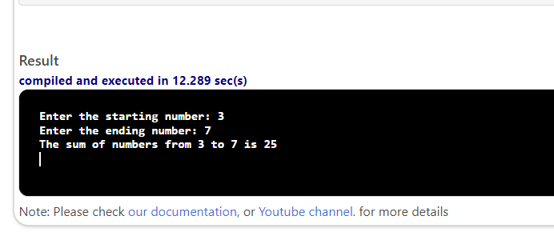
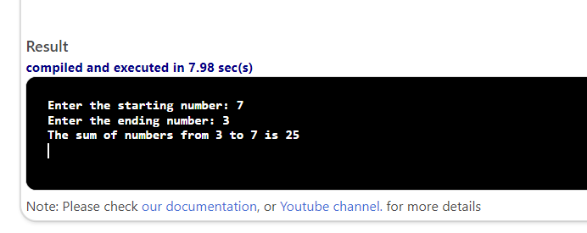

#include <iostream>

using namespace std;
int main()
{
int startNum, endNum, sum = 0;
cout << "Enter the starting number: ";
cin >> startNum;
cout << "Enter the ending number: ";
cin >> endNum;
if (startNum > endNum)
{
int temp;
temp = startNum;
startNum = endNum;
endNum = temp;

}
sum = 0;
int count;
for (count = startNum; count <= endNum; count++)
{
sum = sum + count;
}
cout << "The sum of numbers from " << startNum << " to " << endNum << " is " << sum << endl;
return 0;
}

